Name: Arhum Ahmad

Submitted to Data Glacier on August 10, 2021

Batch code: LISUMO2

Step 1: create the html file

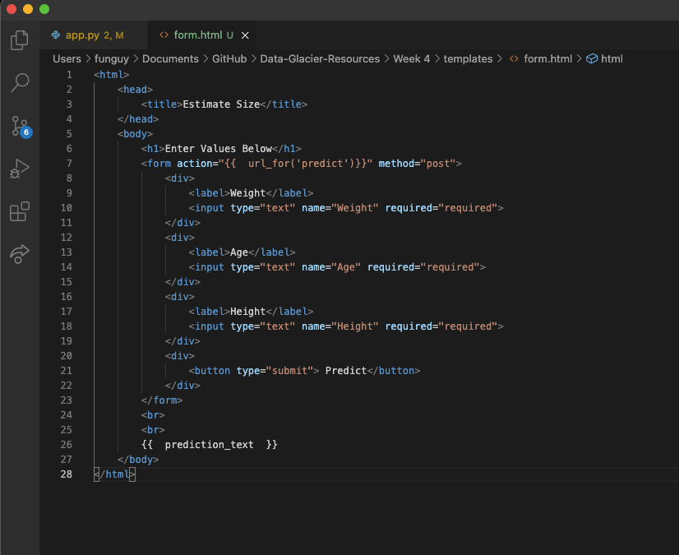

Step 2: write app.py

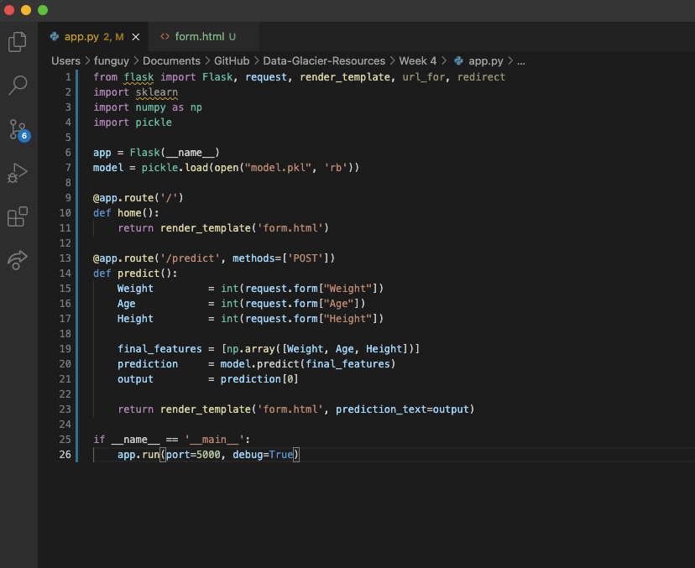

Step 3: Run the application (screenshot taken after data entry was completed)

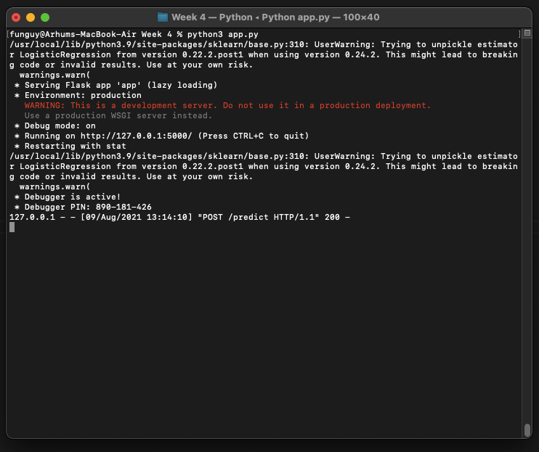

Step 4: data entry / use the model

